Explanation

As part of this code challenge you will be using an API available here: https://swapi.dev/.

We want to know for all SW starships, to cover a given distance, how many stops for resupply are required.

The application will take as input a distance in mega lights (MGLT).

The output should be a collection of all the starships and the total amount of stops required to make the distance between the planets.

All other application details are at your own discretion.

Sample output for 1000000 input:

Y-wing: 74

Millennium Falcon: 9

Rebel Transport: 11

Requirements

1) The completed code should be submitted along with

2) Accompanying documentation

3) Tests and instructions on the usage of the application.

Instructions

⦁ Starships ASP.NET Core MVC, open the Visual Studio 2019 and open the project

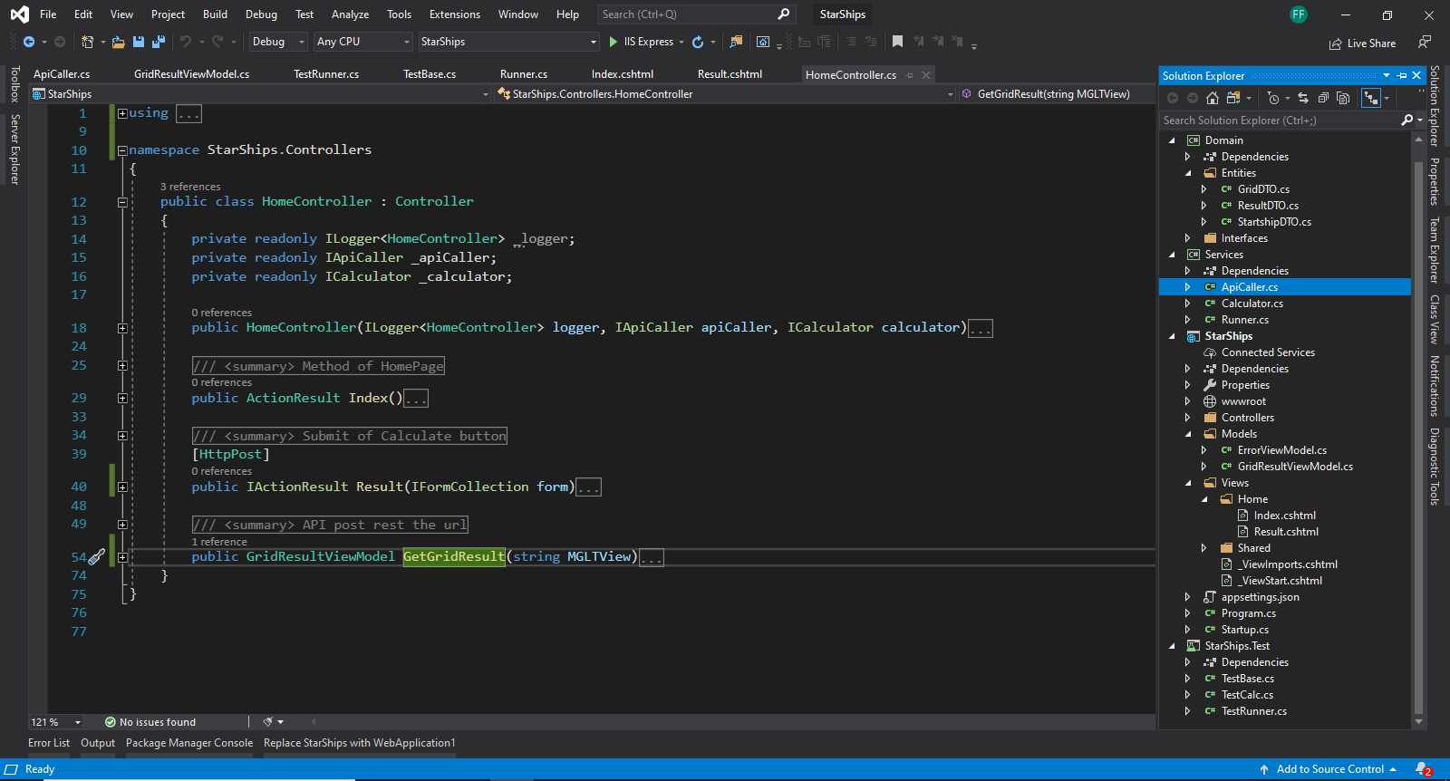

⦁ Insert value in TextBox and click in “Calculate”

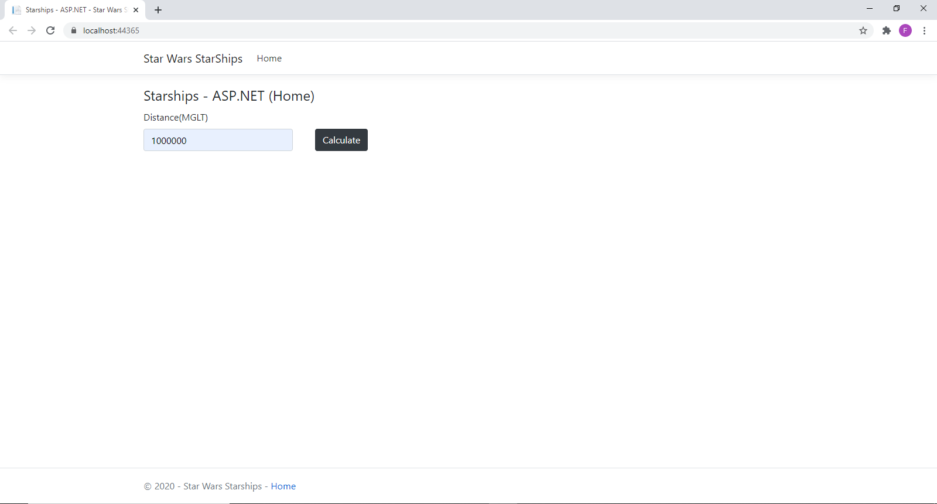

⦁ This View shows the result. If you want to search for another distance, click in “Home” and repeat the 2nd step

